Test Case: tc001_SPX_Dev5_Crear_Requisicion_Spot_Tipo_Cobro_CC
Step 1 - Enter username and password and click to button Enter : Credentials Entered
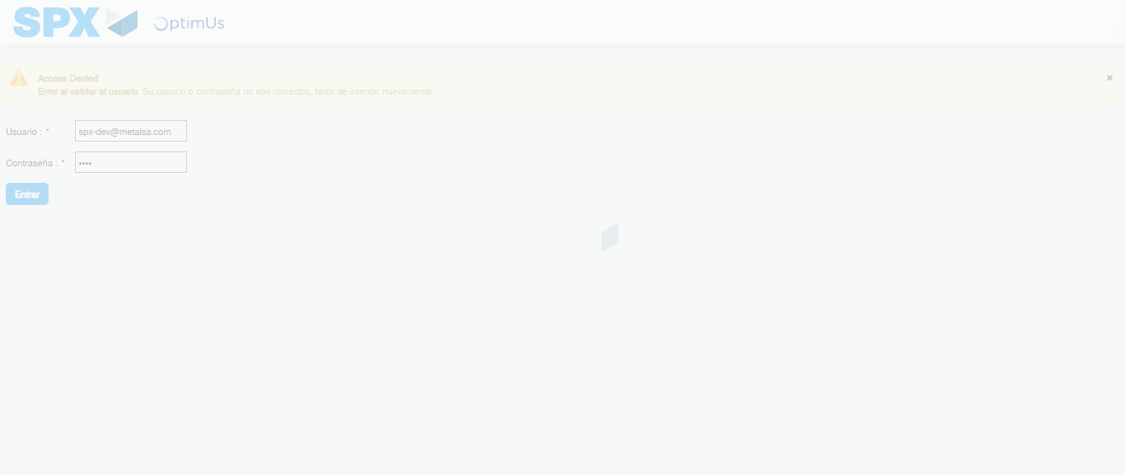Image file-name: QC_Testing-tc001_SPX_Dev5_Crear_Requisicion_Spot_Tipo_Cobro_CC-1789482906360

Step 2 - Select to UEN and Access to Spot Buy Requisitions : UEN Correctly selected and Correct access
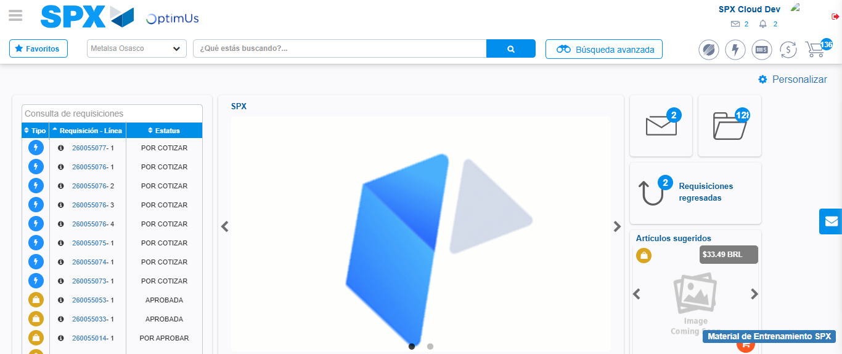Image file-name: QC_Testing-tc001_SPX_Dev5_Crear_Requisicion_Spot_Tipo_Cobro_CC-1789482929767

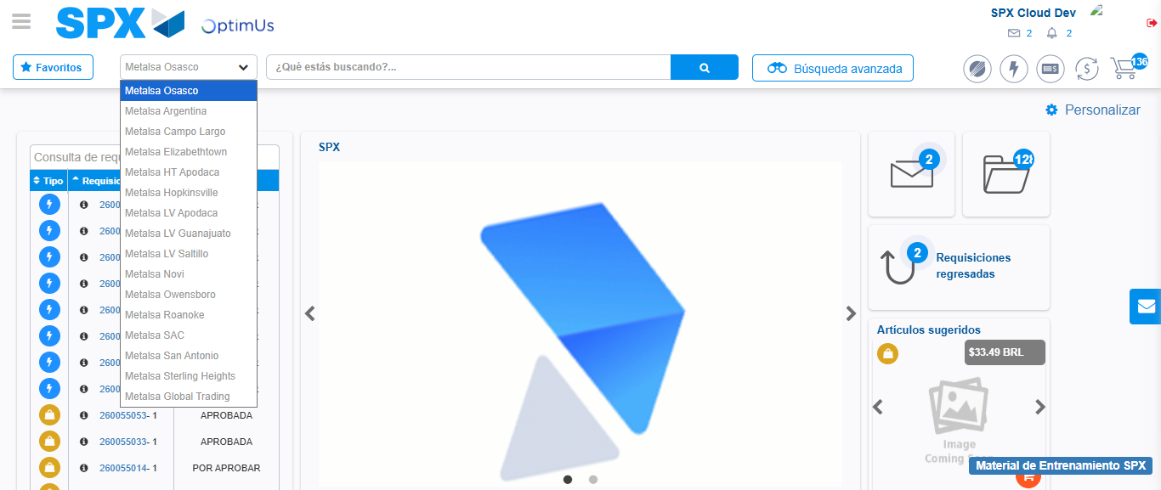Image file-name: QC_Testing-tc001_SPX_Dev5_Crear_Requisicion_Spot_Tipo_Cobro_CC-1789482930466

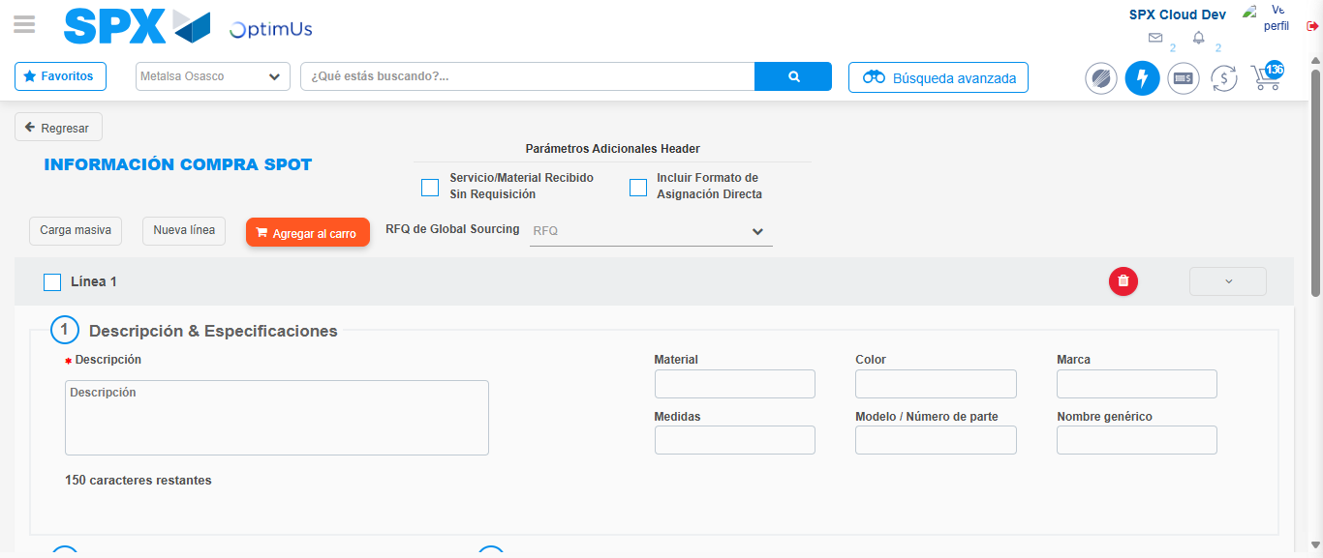Image file-name: QC_Testing-tc001_SPX_Dev5_Crear_Requisicion_Spot_Tipo_Cobro_CC-1789482936862

Step 3 - Data Capture Spot Buy Requisition : Data captured correctly
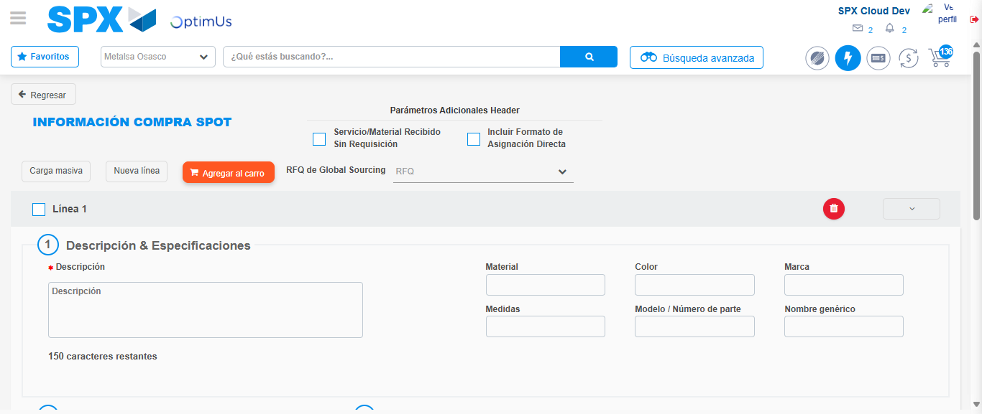Image file-name: QC_Testing-tc001_SPX_Dev5_Crear_Requisicion_Spot_Tipo_Cobro_CC-1789482937144

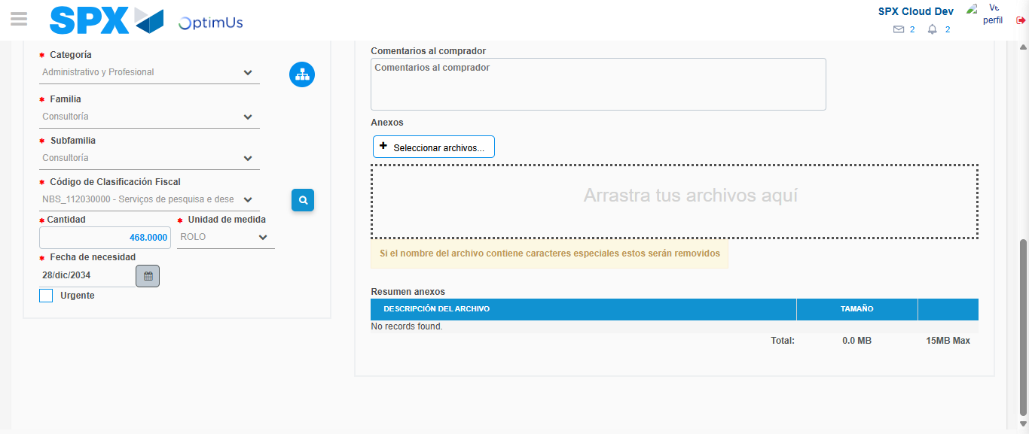Image file-name: QC_Testing-tc001_SPX_Dev5_Crear_Requisicion_Spot_Tipo_Cobro_CC-1789482952179

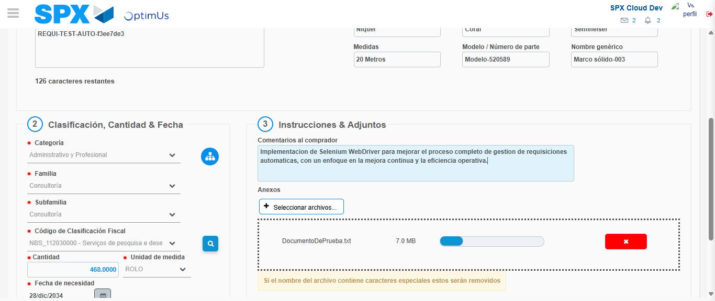Image file-name: QC_Testing-tc001_SPX_Dev5_Crear_Requisicion_Spot_Tipo_Cobro_CC-1789482952897

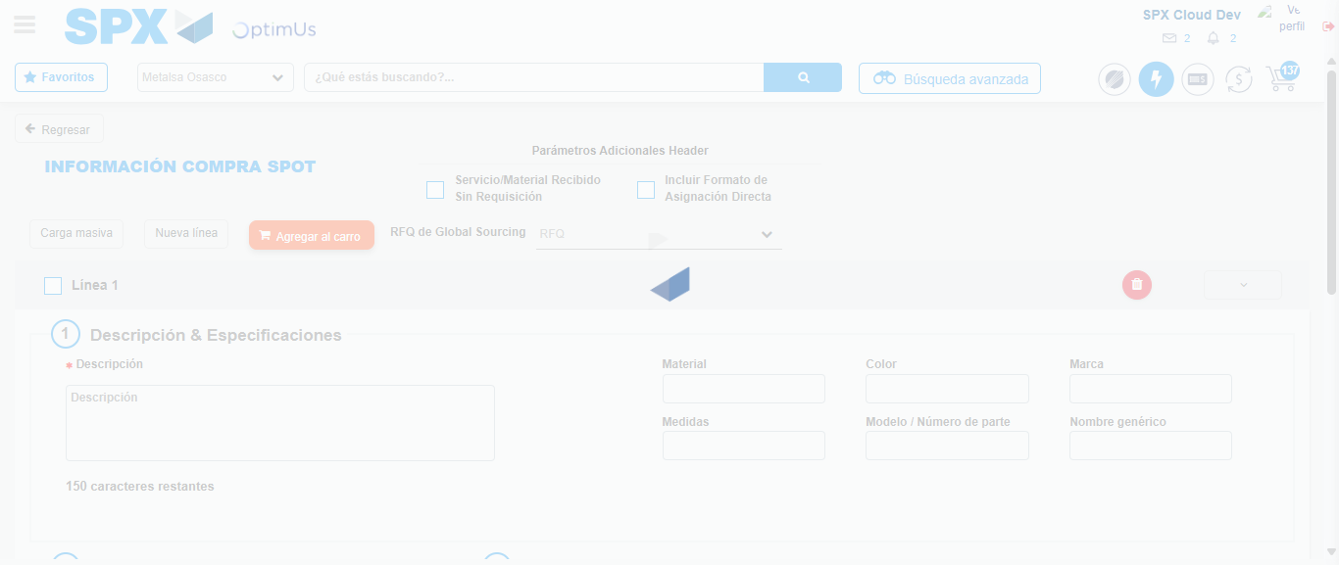Image file-name: QC_Testing-tc001_SPX_Dev5_Crear_Requisicion_Spot_Tipo_Cobro_CC-1789482953772

Step 7 - Return to Main Page SPX : Return to Main Page SPX
Image file-name: QC_Testing-tc001_SPX_Dev5_Crear_Requisicion_Spot_Tipo_Cobro_CC-1789482929767

Image file-name: QC_Testing-tc001_SPX_Dev5_Crear_Requisicion_Spot_Tipo_Cobro_CC-1789482930466

Image file-name: QC_Testing-tc001_SPX_Dev5_Crear_Requisicion_Spot_Tipo_Cobro_CC-1789482936862

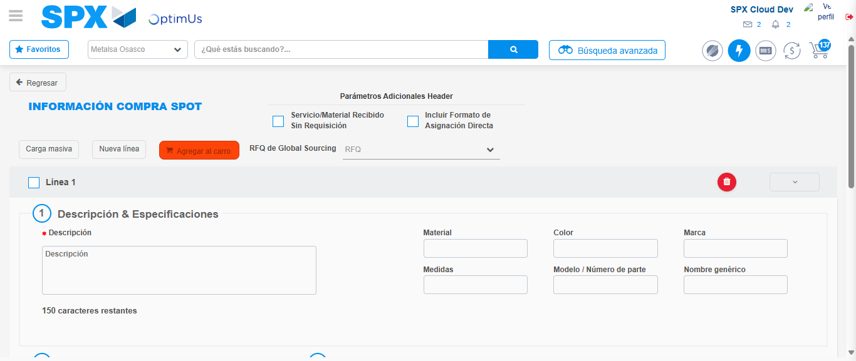Image file-name: QC_Testing-tc001_SPX_Dev5_Crear_Requisicion_Spot_Tipo_Cobro_CC-1789482955975

Image file-name: QC_Testing-tc001_SPX_Dev5_Crear_Requisicion_Spot_Tipo_Cobro_CC-1789482956157

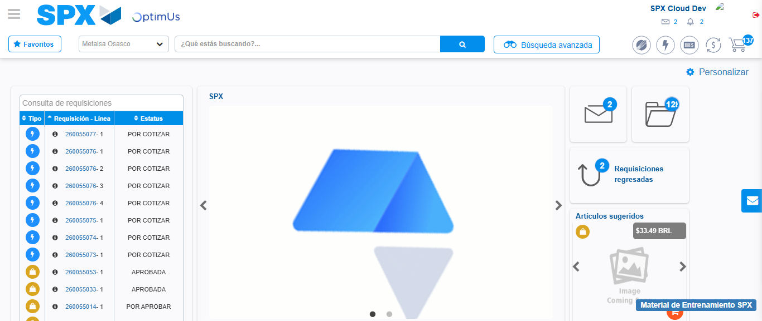Image file-name: QC_Testing-tc001_SPX_Dev5_Crear_Requisicion_Spot_Tipo_Cobro_CC-1789482977272

Step 8 - Log Out : Log Out SPX
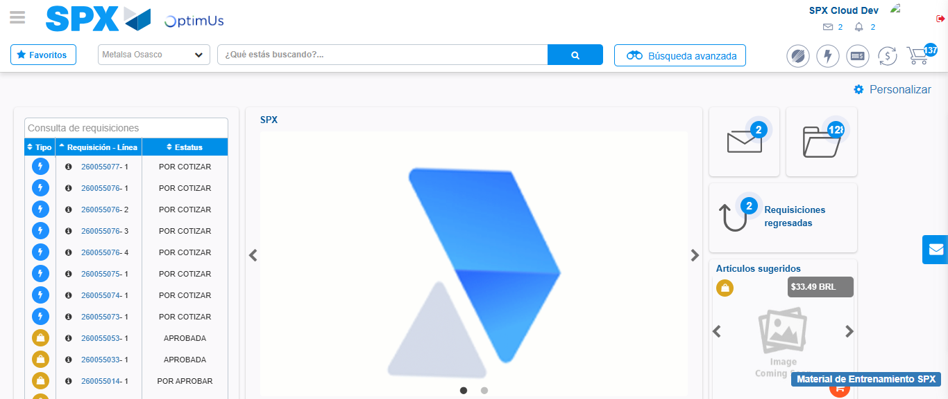Image file-name: QC_Testing-tc001_SPX_Dev5_Crear_Requisicion_Spot_Tipo_Cobro_CC-1789482977543

